ADVENTURE AND TREKKING WEBSITE
WILTRAILS – Explore • Discover • Adventure

1. Project Description
WildTrails is an adventure and trekking website designed for people who love mountains, nature, camping, and outdoor activities. The website introduces popular destinations, adventure activities, and information about the travel experience. Its main aim is to help visitors discover exciting outdoor experiences through a simple and attractive web page.
The page contains a navigation bar with links to Home, Destinations, Activities, About, Packages, and Contact. The home section welcomes visitors with the message “The Wild Is Calling You” and provides an Explore Destinations link.

2. HTML Code
HTML (HyperText Markup Language) is used to create the structure and content of the website. The code shown below includes the page body, navigation header, hero section, heading, introduction, and a button that links to the destinations section.
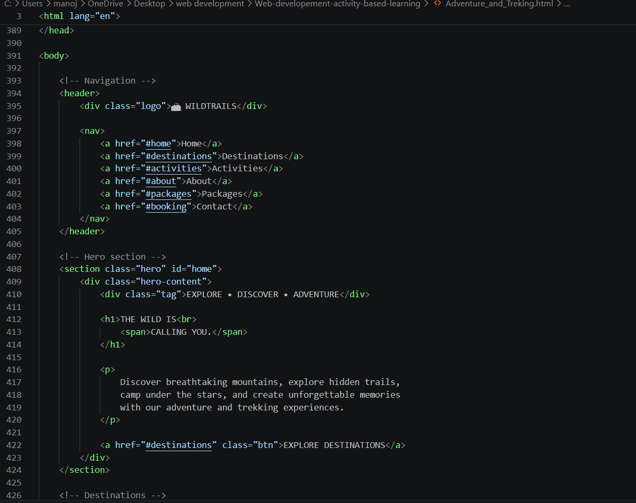
Figure 1: HTML structure of the WildTrails website

3. CSS Code
CSS (Cascading Style Sheets) is used to control the appearance and layout of the website. The styles shown include the page reset, font family, background and text colors, navigation bar layout, sticky header behavior, and logo styling. These styles give the website a clean outdoor-inspired look.
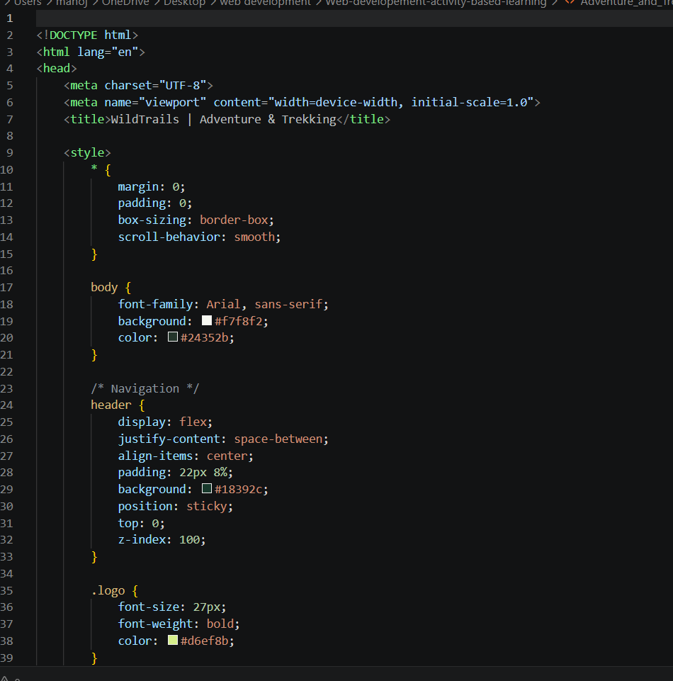
Figure 2: CSS styling used for the WildTrails website

4. Website Output
The final output displays the WildTrails adventure website. It features a mountain background in the hero area, a navigation menu, popular destination cards, activity sections, and an About WildTrails section. The green and white color combination supports the nature and trekking theme. The layout presents the information in a clear and visually appealing way.
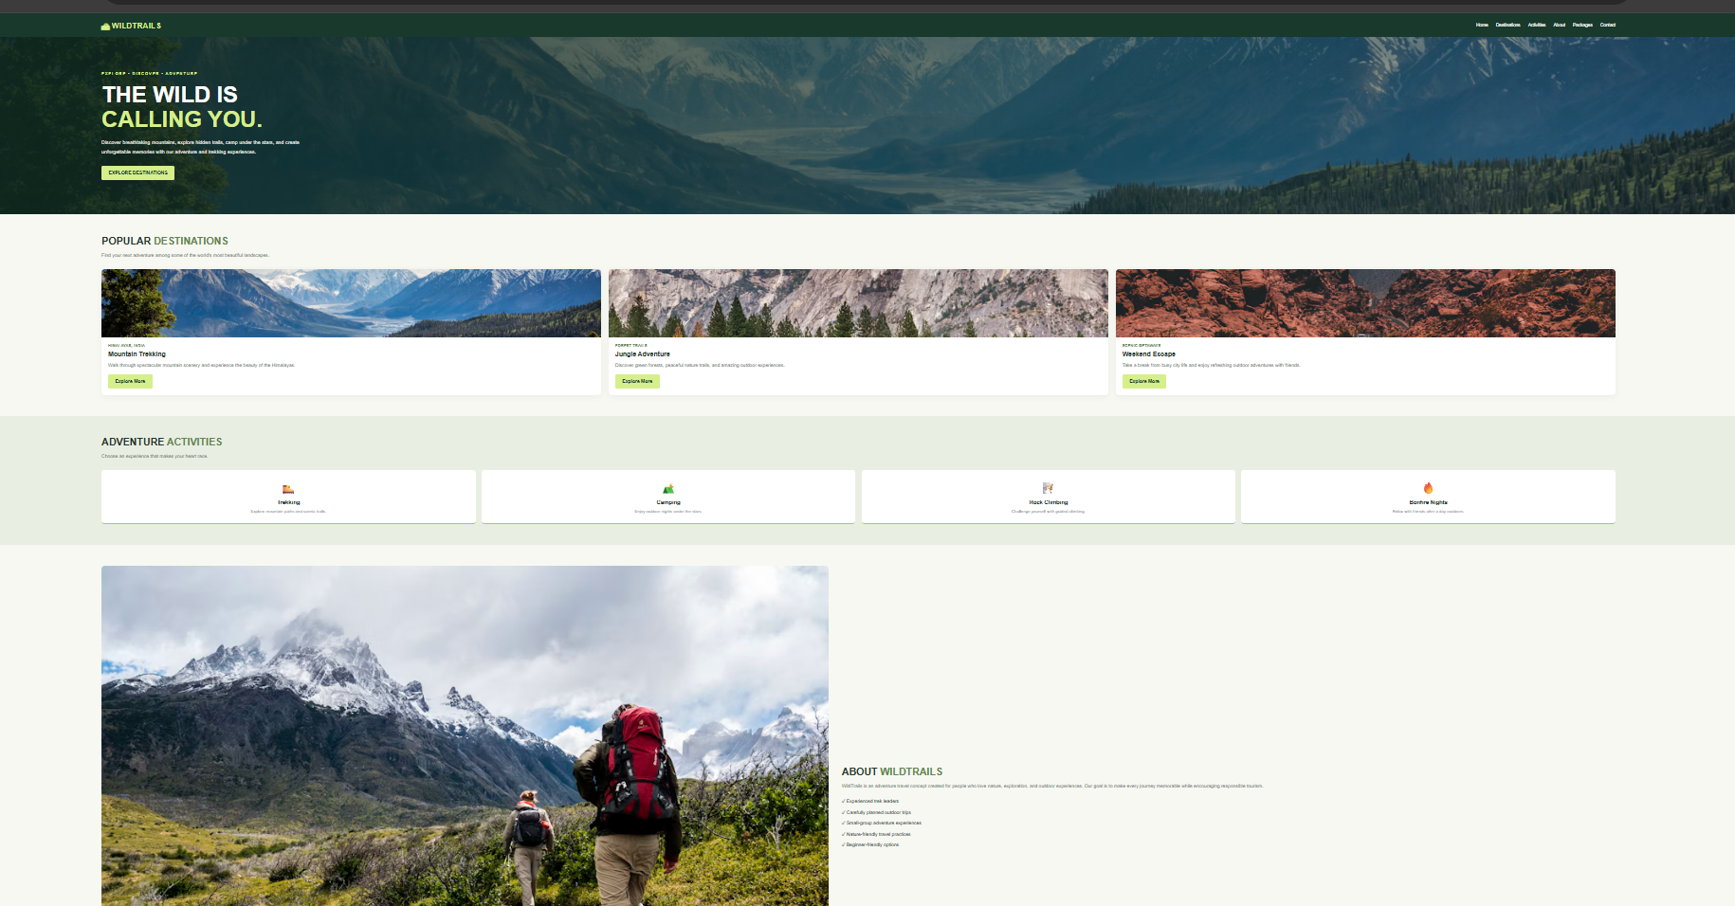
Figure 3: Final output of the Adventure and Trekking website

5. Conclusion
The Adventure and Trekking website was created using HTML and CSS. HTML provides the structure, while CSS improves the design, colors, spacing, and overall appearance. This project demonstrates how a simple and informative website can be developed to promote adventure destinations and outdoor activities.

